=

Point A: Baruch College: The William and Anita Newman Vertical Campus

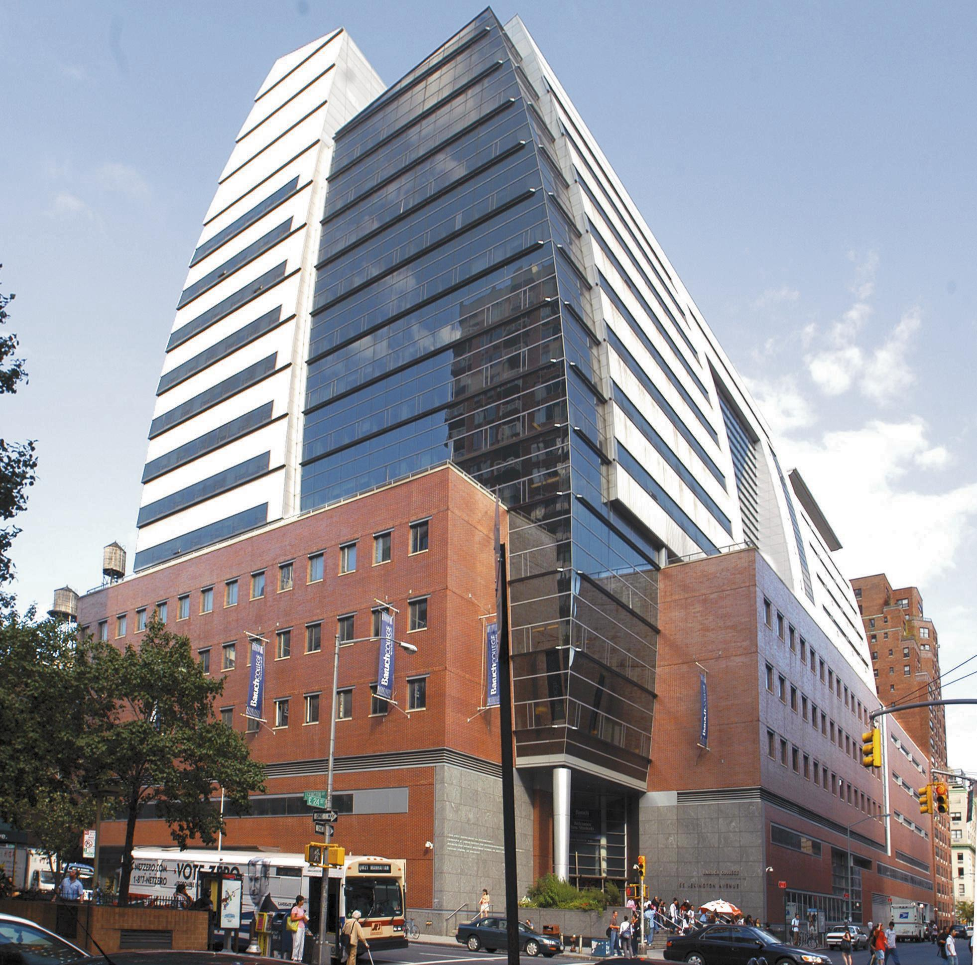

Quote: “I discover myself on the verge of a usual mistake.”- Song Of Myself

Explanation: This quote in particular pulled me in and immediately grabbed my attention, and made me think of the very building, which I am very proud to say where I attend College. Its what the building itself represents to the thousands of students that attend classes there everyday. A place where someone eagerly can mold there young minds and gradually seeing themselves achieving what they themselves thought was unbelievable. The person they eventually would want to become some day, and you may

