Sergio Rivera
Professor. Hussey
English 2850
10-22-15

MOMA Assignment- Van Gogh’s Starry Night

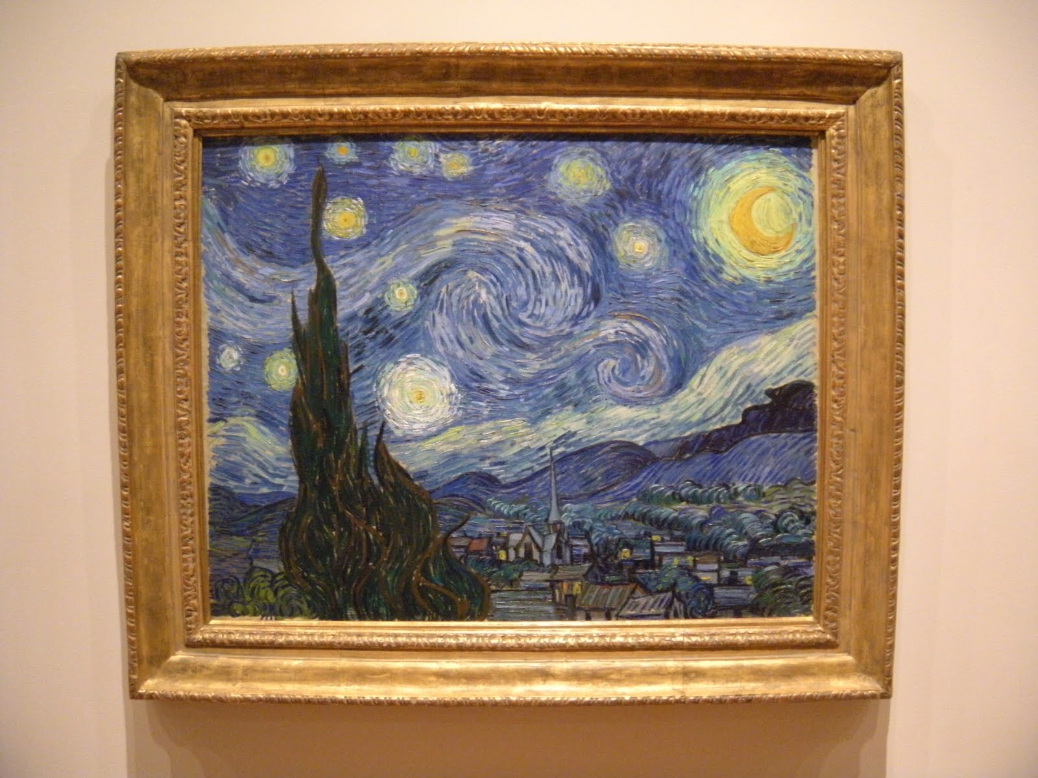

Van Gogh painted this piece in 1889 while he was in Saint Rémy in southern France, seeking treatment in a mental asylum. Interestingly however, he painted this piece from his memory and it was supposed to have been based on a constellation arrangement he had seen earlier on in the night sky of Provence. Starry Night is perhaps one of his most famous works and yet is one his most difficult to understand.

If I were depict this painting apart, piece by piece, the first thing that I noticed was the night sky which takes up most of the background of the painting. Its swirling, flowing lines appear to be swishing across the background in this wavy motion and seem to be merging at the center to form this spiral-like formation. I count Eleven fiery yellow stars that to me look like huge fireballs and they illuminate this whole painting and juxtapose with the cool blue, the night sky also displays an amazing quality of shades of blue and grey. There is also the crescent moon at the top right hand corner that emits a more orange, and it's light seems to be brighter from the rest of the stars. The view of the night sky and the village is blocked partly by this huge bush in the foreground. It has this was a continual twisting or swirling quality to it, it almost border on the idea of being an optical illusion. The black and green also stands out to the rest of the piece. The houses are tiny and are not clearly visible or attracting any attention and they are painted in the bottom right corner of the painting and merge well with the forest and mountains. The architecture of the village is unusual in my view and simple and the villages seems to be in the darkness seeing as no light illuminates the village, giving the impression that everyone there is probably asleep.

My interpretation of Starry Night is just one of the many and it remains very much a work of art that many critics and students alike have difficulty understanding. Because nobody really knows Van Gogh's intention of painting this piece, everybody seems to be using different ways of analyzing the painting to decode what Van Gogh was trying to bring across. One critic thought of this as "a religious piece depicting a story from the Bible. In the book of Genesis, Joseph has a dream of eleven stars, the sun and moon (the moon and sun appear to be merged together here) that symbolised his brothers and parents bowing down to him". Another academic thought this painting was "to be a convergence of historical forces as it was during this time when there was a public fascination with astronomy and astrology with people like Jules Verne writing about travelling to the moon".

Ultimately in my opinion, Van Gogh conveys a message of tremendous hope in this masterpiece. Like the people living in the town in the painting, even if our troubles that we as mankind encounter in our day to day lives and as they continue to happen, that fails in compassion to the vast universe our beautiful planet resides in, and it makes everything that occurs on earth somehow irrelevant . Someone however, can interpret this painting as the people in the town being assured that God has heard the people's cries, and has acted to calm their fears, heal their pain and suffering.

