Chandani Ramkishun
IDC
William Glackens: A New York City Observer
William James Glackens was an exemplary painter from the late 19th century to the early 20th century. Glackens was born in 1870 in Philadelphia, Pennsylvania (The Phillips Collection). Throughout high school, Glackens was involved in a realist painting group known as the Eight. The group made their mark in the art establishment with its modern urban scenes that deviated from the traditional matter. Of all the members, Glackens was most influenced by impressionist paintings. Glackens visited several countries in Europe in 1906, such as the Netherlands and France, and began to depict outdoor scenes (Terra Foundation). After finishing his education at the Pennsylvania Academy of Fine Arts, he moved to New York. Glackens married Edith Dimock, and artist from Hartford. Glackens was under the influence of Robert Henri, who encouraged the Eight to paint modern life (NY Times). His group of Eight had their own exhibition in New York in 1908. After his art sales started to take off, Glackens began to open art exhibitions such as the Armory Show in 1913. In 1917, he became the first president of the Society of Independent Artists (The Phillips Collection). At the age of sixty-eight, Glackens passed away in 1938 from unknown causes. After his death, Glackens was awarded a memorial exhibit at the Whitney Museum of Natural Art (Terra Foundation).
The time period of the early 20th century heavily influenced Glackens’ work. In 1906, he went through a dramatic change in his palette. Glackens’ artwork focused on things surrounding him. “This included mostly public parks, people relaxing at the seashore and portraits or interior scenes involving family and friends” (NY Times). In the midst of the city, Glackens depicts the stereotypical New Yorkers. His painting feature people in motion in places such as parks. “Glackens also made a specialty of painting New York City's parks, typically showing them filled with a variety of social types enjoying themselves in all seasons, especially winter,” (Terra Foundation).
Glackens had many pieces that depicted the daily lives of New Yorkers in several outdoors locations. He would often observe from his studio apartment or go outside to witness the New York lifestyle. Glackens would watch people specifically in Washington Square Park all year long. His paintings all had a message regarding New York City.
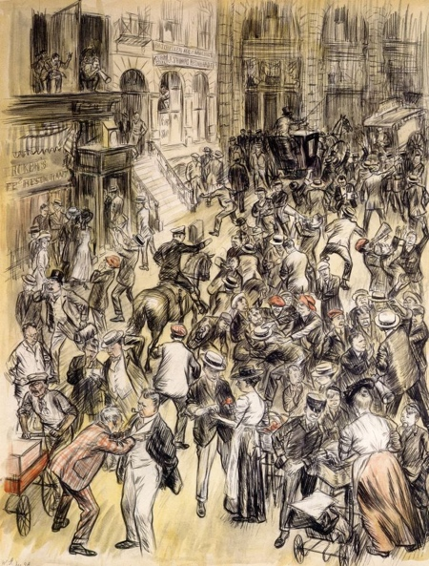
For example, Glackens’ painting “The Curb Exchange” features a transaction on Wall Street. The painting has two focal points, “the exchange taking place between the male stock traders on the street and the woman selling apples” (Colleary). The painting has a play on words on the word, “exchange.” Glackens shows the exchange between the woman and boy with apples and the stock exchange men in suits arguing. This painting relates to the economic time period because it deals with the exchange between brokers from the New York Stock Exchange.
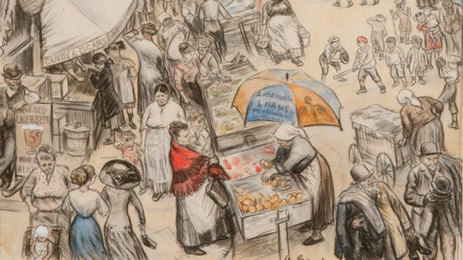
Another painting that was set in New York City was “Far from the Fresh Air Farm.” The painting shows lower class women at the market place selling foods to earn a living as a way to provide for families (Colleary). This painting depicts the struggling lives of immigrants to earn money as they just arrived to the city. The painting’s primary focus is the street vendor, selling what appears to be bread under the umbrella. The rest of the painting is drawn in dull colors. However, the red shawl stands out immediately to the eye.
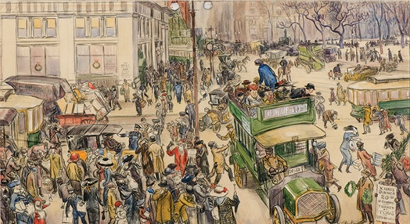
Glackens’ watercolor art in “Christmas Shoppers, Madison Square” brings to life the busy streets of New York City during the holiday season (Colleary). The artwork is full of color as compared to his other works, to show the spirit of Manhattan during Christmas.
The canvas, “The Green Car” is taken place in Washington Park. Glackens’ inspiration comes from the fact that he lived in a studio in Washington Square, in Greenwich Village (metmuseum.org). He was a keen observer of the people and locations around him. That is how he got the inspiration for this art piece. The painting shows a women dressed in high standard fashion, waiting on the green car for a ride.
Furthermore, the painting “Tugboat and Lighter” also tells a story of the New York City time period. The oil on canvas painting is of the New York harbor (Colleary). The painting relates to the active trading and ports at New York. At this time, New York was a successful commercial enterprise. Focused on profits, New York had grand opportunities in trading. This gave New York a distinctive power in the United States. In the far back of the scene the painting behind the fog and mist, stands the Statue of Liberty.
The painting “Sledding in Central Park” shows a little Scottish boy with a red sled (Colleary). The painting sets a scene in another New York landmark, Central Park. The painting shows that even in the cold season, New Yorkers still find outdoor activities to do. New York, unlike other places around the world, has four seasons, each different from each other.
The painting, “Mother with a Baby, Washington Square Park” is another art piece that Glackens viewed from his apartment. This painting, as noted in the title, also takes place in Washington Square Park. The color of the trees indicate that it is Spring, with pink flowers blooming on the trees. The woman is cradling her baby in her arms, “perhaps a resident of the lower-class Italian neighborhood that bordered the park on the south” (Colleary).
William Glackens’ paintings give a visual tour of the urban and colorful life of New York City. Most of his paintings that were set in New York, took place in Washington Square Park since he resided in an apartment near the park. Glackens frequently moved around and after staying in New York he traveled again into Europe.

Works Cited

Colleary, Elizabeth Thompson. “Highlights from The William J. Glackens Collection in the NSU
Art Museum Fort Lauderdale”. PDF http://nsuartmuseum.org/wp-content/uploads/2015/03/Final-Commentaries-on-Works-in-the-Glackens-Collection.pdf

Smith, Roberta. "The Beauty of the Everyday." The New York Times. The New York Times, 14
Aug. 2014. Web. 20 Sept. 2016 <http://www.nytimes.com/2014/08/15/arts/design/william-
glackens-spent-a-life-painting-what-was-before-him.html?_r=0>.

"William Glackens - Bio." William Glackens - Bio. Phillips Collection, n.d. Web. 20 Sept. 2016. <http://www.phillipscollection.org/research/american_art/bios/glackens-bio.htm>.

“William Glackens”. Terra Foundation,
http://collection.terraamericanart.org/view/people/asitem/items$0040null:220/0. Accessed 20 September 2016.

"William James Glackens | The Green Car | The Met." The Metropolitan Museum of Art, I.e. The
Met Museum. N.p., n.d. Web. 20 Sept. 2016. <http://www.metmuseum.org/art/collection/search/19294>.

